- Run outer perimeter of the site and capture the rosbag data. After pressing Start in the GUI, wait for the green icon indicating RTK fix, then record all data.
- You will then convert the rosbag file into a .csv file. (e.g. Site_01.csv).
- Confirm/update the parameters in /home/tractor/ros1_lawn_tractor_ws/project_notes/paths/paths_locations.csv (e.g. the starting point, number of rings)
- Run ~/path_ll2xy_2inner_rings_v4.py. This will create separate files for each ring. The largest value (e.g. Site_01_ring_5.csv) is the innermost ring.
- Open /home/tractor/ros1_lawn_tractor_ws/project_notes/code_for_testing/archive/boustrophedon/path_boustrophedon_coverage_variable_degree.py
- Update ‘csv_path’ with the filename of the innermost ring to use
- Run the program and adjust the degree’s until you are happy (i.e. path = main(19)). I used 19 degree lines. The output will be used as input for ~/archive/boustrophedon/plotIntersectingPointsV8.py
- After running path_boustrophedon_coverage_variable_degree.py the stripes are defined but the Dubin’s ‘keyhole’ u-turns are not. To do that the intersection points that will define the start and stop of the u-turns need to be defined.
- Open the script: ~/archive/boustrophedon/plotIntersectingPointsV8.py
  - Update lines:
    - file_path = '/home/tractor/ros1_lawn_tractor_ws/project_notes/paths/Collins_Dr_62/Site_01_path2.csv'
    - first_rows_to_remove = 3
    - end_rows_to_remove = 12
    - output_path = '/home/tractor/ros1_lawn_tractor_ws/project_notes/paths/Collins_Dr_62/Site_01_path_with_intercepts2.csv'
- You will see plots before and after trimming the lines. Update the script to delete the beginning and ending line segments that will be handled by outer perimeter runs. (i.e. The lines that are short or have multi-paths, disconnected line segments.
- (TODO: Update the logic to look for disconnected line segments)
- Open ~/paths/Collins_Dr_62/Site_01_boustrophedon_line_segments_with_intercepts.csv. Select ‘comma’ as the separator option.
- It will have: x1, y1, x2, y2, upper_intercept_x, upper_intercept_y, lower_intercept_x, lower_intercept_y
- Open ‘Site_01_path_with_intercepts_master_v2.ods’ and save a new copy (e.g. Site_01_boustrophedon_w_formulas_v1.ods)
- Clear out the existing data from B2 to I{last row}
- Copy A2 to the end of Col H from ‘Site_01_boustrophedon_line_segments_with_intercepts.csv’
- Go to B4, paste special ‘number’
- Adjust the start point (Row 4, Col N) should be the end point of the perimeter run
- Make note of which row the values of Col N start to become 0’s. This is the end of the path to copy.
- Open ~/ros1_lawn_tractor_ws/project_notes/code_for_testing/path_planner_stable/path_planning_waypoint_generator.py
  - Adjust/confirm {input_file_waypoints} name (e.g. /Site_01_boustrophen_generator_input.txt")
  - Adjust speed to 0.75 for field work (2.5 for simulation)
- Open {input_file_waypoints}; Select all and delete (Ctrl+A), (Ctrl+X)
- Go back to the spreadsheet and copy the x, y and angle to input file (Col’s N, O and P). The angles should be theta or theta + pi() (180 degrees from each other)
- Paste the values into {input_file_waypoints} and Ctrl+S to save the file
- Run $ python3 ~/ros1_lawn_tractor_ws/project_notes/code_for_testing/path_planner_stable/path_planning_waypoint_generator.py
- This is to get an idea of how many corrections are needed.

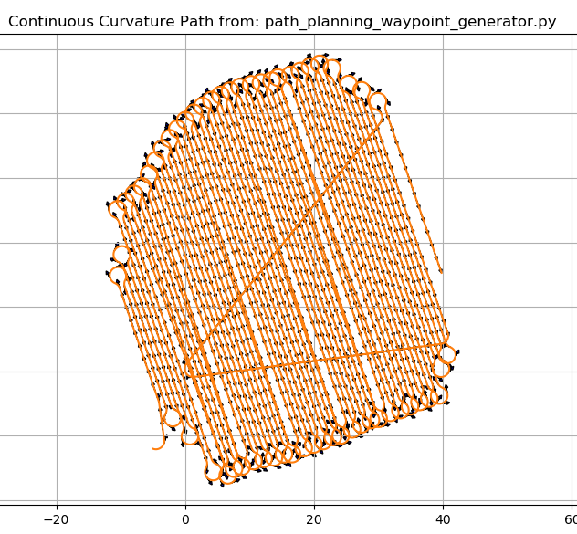

- In this example the visible issues are:
  - The end points are not correct
    - At line 121 there is a (0, 0) point which is an obvious error.
      - Look at line 119 and 120 to determine where 121 should really be pointing to.
        - You can see the x, x+1 then y, y+1 pattern
        - The lines at the end were ‘visually crafted’. The (0, 0) was triggered by overrunning the number of valid line segments
        - I manually deleted the lines from the .txt file
  - There are ~6 points where the start and end points of the u-turn are nearly the same point which causes the open spaces in the middle of the overall path.
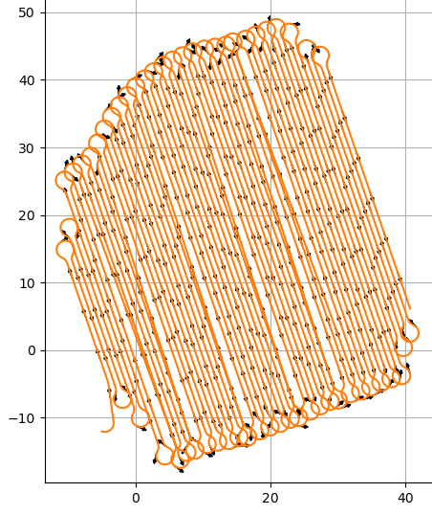

- Reviewing ‘near equal start and end points’
  - 5.9, -14.9
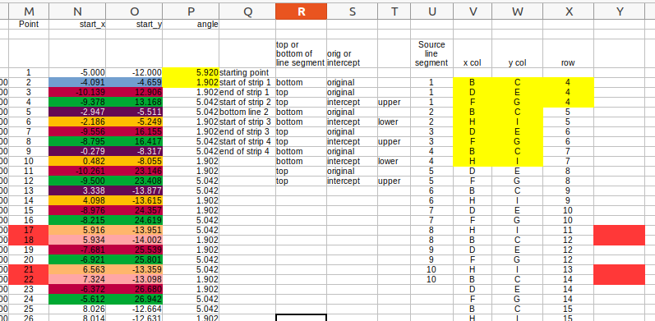
- Look on the actual path and determine with point will make a 0.9 meter path; Then determine which point will deliver that and which column, row that point is on; Adjust the spreadsheet to change that point. The ‘x’ value should be less by about 0.9 meters.
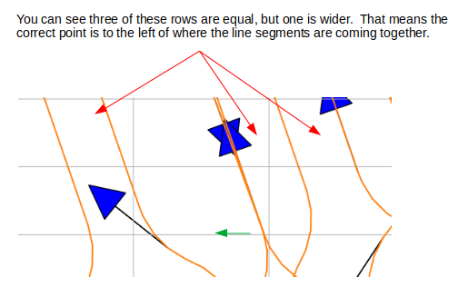

- In other areas I had the instructions “Swap H I to BC, add 1 to line number” so trying that here.
- After about 6-7 changes similar to the one above, path is looking better.

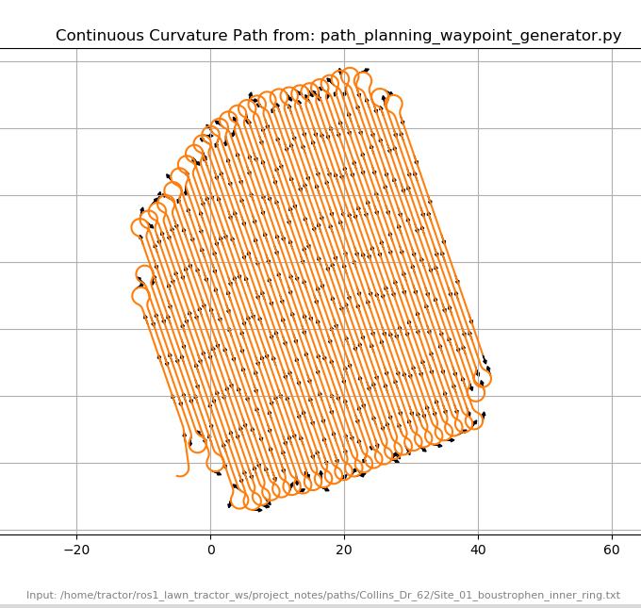

- Open ~/code_for_testing/archive/boustrophedon/path_test_update_input_file.py This is a helper program to copy the data from the spreadsheet to the .txt input file. Change filenames and the end data point. Run this after you have made changes to the spreadsheet and want to visualize the changes.
- Open ~/ros1_lawn_tractor_ws/project_notes/code_for_testing/archive/boustrophedon/path_test_plot_before_running_simulation.py and confirm the input filenames
- Run python3 /home/tractor/ros1_lawn_tractor_ws/project_notes/code_for_testing/archive/boustrophedon/path_test_plot_before_running_simulation.py which will show how the Boustrophedon and outer ring path overlay.

If you want to adjust the lengths of the uturn line segments:
- Open /code_for_testing/archive/boustrophedon/path_test_adjust_line_segment_length.py
- Look at the spreadsheet and see which row the data starts on. Look at the Col K. The point values are listed. If you want to change points 3 and 4 you need to note the spreadsheet row for point 2 because the math needs points 2-5, which is row 5.
- Update ‘starting_row_of_data’ in the program to ‘2’
- Change the adjustment value ‘length_to_shorten’. Negatives to extend a line, positive to shorten a line segment.
- After running path_test_adjust_line_segment_length.py copy the new start/stop x, y values to the spreadsheet
- Copy spreadsheet data, run ~/archive/boustrophedon/path_test_update_input_file.py
- Run $ python3 ~/ros1_lawn_tractor_ws/project_notes/code_for_testing/path_planner_stable/path_planning_waypoint_generator.py
- Run python3 /home/tractor/ros1_lawn_tractor_ws/project_notes/code_for_testing/archive/boustrophedon/path_test_plot_before_running_simulation.py which will show how the Boustrophedon and outer ring path overlay.

- Once you are happy you can combine this with the ‘outer rings’ file and save it as ‘paths_input.txt’ in the ‘ready_to_test’ folder.
- The path for the inner rings should be run in simulation as a safety measure.

